**Faculty of Engineering**

**Credit hours system**



**Communications-1**

**EECS306**

**PCM Project**

|  |  |
| --- | --- |
| Rawan Yasser Hashem | **1210008** |
| Youssef Ahmed Abdelbar | **1210090** |

**Defining the Used Parameters**

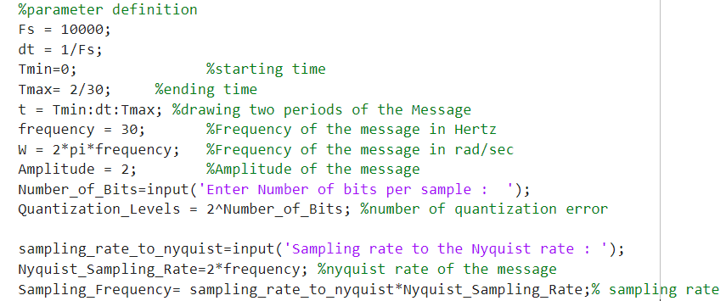

Fig.1

Start by defining the time interval the signal will be drawn in , and defining the frequency of the signal , the amplitude , and get from the user the number of bits per sample and calculate the number of quantization levels , calculating the Nyquist sampling frequency and get from the user the sampling rate to the Nyquist rate to obtain the sampling frequency.

**Generating the Message Signal**

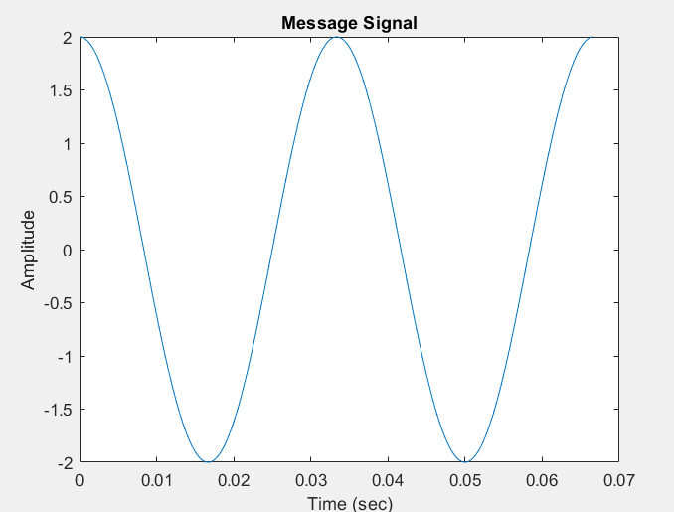

Fig.2

This analog signal, has a frequency **30 Hz** and a peak amplitude of **2 volt**, is generated by using the following code(Fig.3):

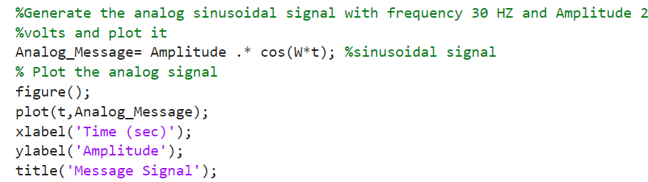

Fig.3

**Requirement 1**

**(If the Sampling rate equals the Nyquist rate)**

**(8 level quantizer)**

**1- The Sampled Signal**

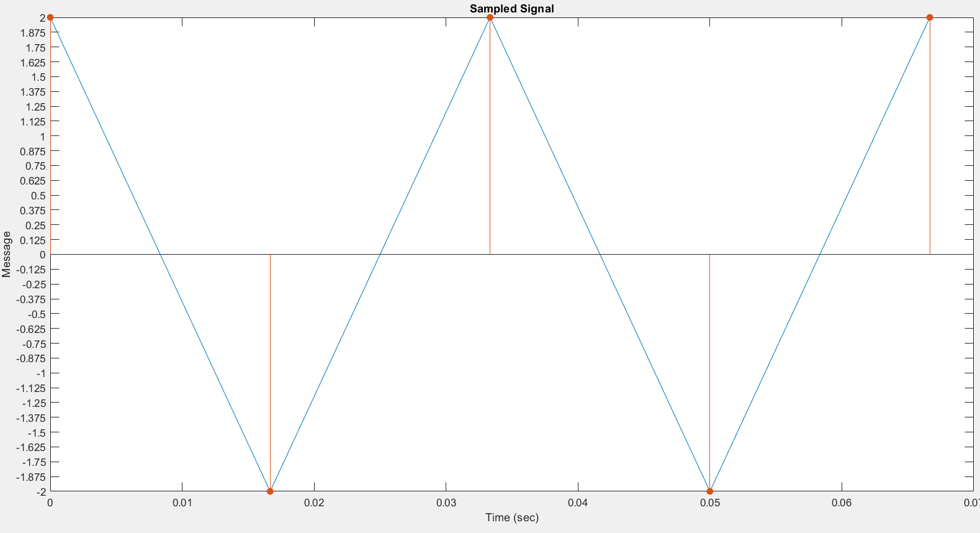

Fig.4

Here, Sampling frequency = NR = 2*Fm = 60 Hz and Ts = 1/Fs = 1/60 sec.

So, we can see (fig.4) that the samples are taken every half period

And it’s generated by the following code:

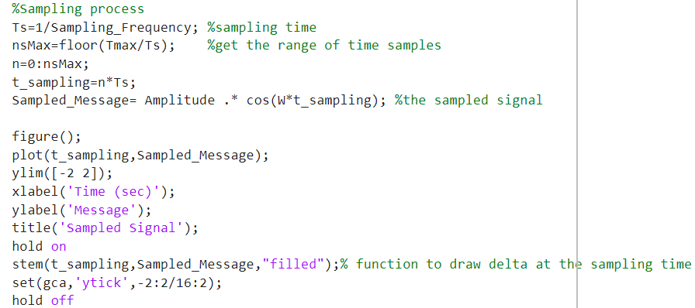

Fig.5

Where, t_sampling = n*Ts and stem is a function that draws deltas at the sampling time

**2- Quantized Signal**

Here in this case, we used number of bits per sample “n” = 3 bits. So, we have number of levels “L” = 2^3 = 8 levels

Calculating the step size: Step_size = (Vmax - Vmin) / Quantization_Levels; Since, Vmax = 2 and Vmin = -2, we got step size = 0.5

Taking the levels as midrise and doing the quantization process by a function “quantiz”:

[index , Quantized_value] = quantiz (Sampled_Message , partition , codebook);

Where, “Partition” makes partitions between Vmax and Vmin with a difference of a step size: partition = Vmin : Step_size : Vmax; And “Codebook” expresses the quantization value for each partition :

codebook = Vmin-(Step_size/2) : Step_size : Vmax+(Step_size/2);

Then, the first output is array named “index” which determines to which level each sample belongs and second output is array named “quantized_value” which is the output of the quantizer that contains the quantization values of the input signal to each sample.

So, at the end we have levels at -1.75:0.5:1.75 , and the samples are quantized as shown in fig.6:

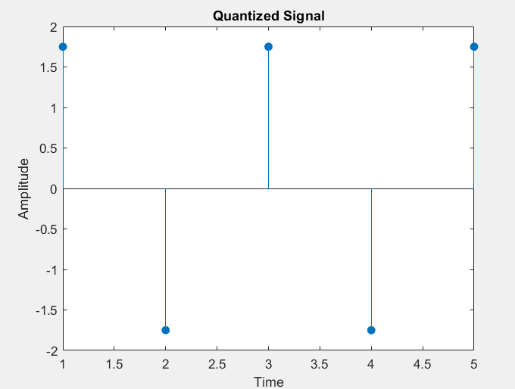

Fig.6

**3- Encoded Signal**

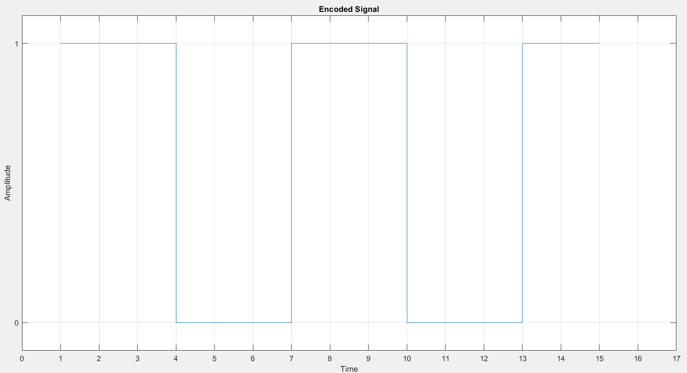

Fig.7

As it is clarified it is a stream of bits and used code is unipolar NRZ to represent this stream of bits, to get this stream of bits we used the following code , there is matrix called code and obtained using function de2bi which convert each leveled sample to binary, in this matrix the row has binary code for a sample . so, to get the stream of bits in 1-D array we did this loop and got the stream of bits in coded.

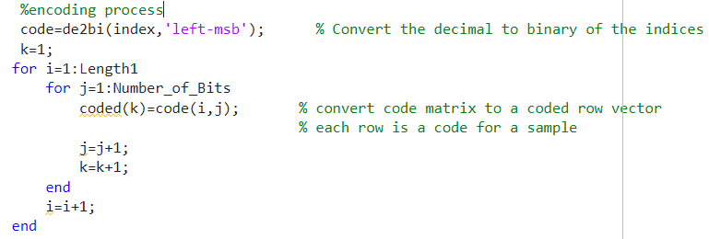

Fig.8

**4- Recovered Signal**

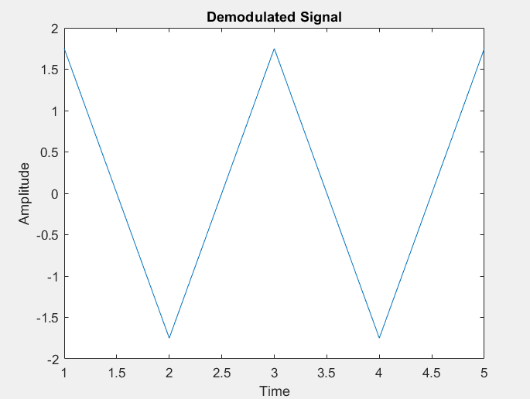

Fig.9

As we can see, the recovered signal is not the same as the sampled signal, since there is a distortion introduced by the quantization process, and the small number of samples which lead to recover a signal not like the message signal.

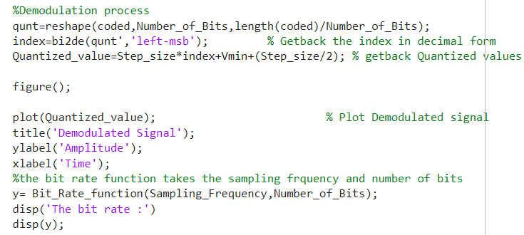

Fig.10

As illustrated in fig.10 function reshape returns matrix qunt this matrix each column contains the code of a sample ,column 1 has binary code of sample 1 and column 2 has the binary code of sample 2 … ,

To get the decimal number of the quantized level to re-draw the demodulated signal is by using function bi2de and take the transpose of matrix qunt to read the first sample binary code and convert it into decimal , and get back the quantized value using Quantized_value = Step_size*index + Vmin+step_size/2.

**5- Bit Rate** (n*Fs)

Building a function that calculates the bit rate:

function result = Bit_Rate_function(Sampling_rate,Number_of_Bits)

result = Sampling_rate*Number_of_Bits;

end

We got Rb = 3*60 = 180 bps

**Requirement 2**

**(If the Sampling rate is twice the Nyquist rate)**

**(8 level quantizer)**

**1- The Sampled Signal**

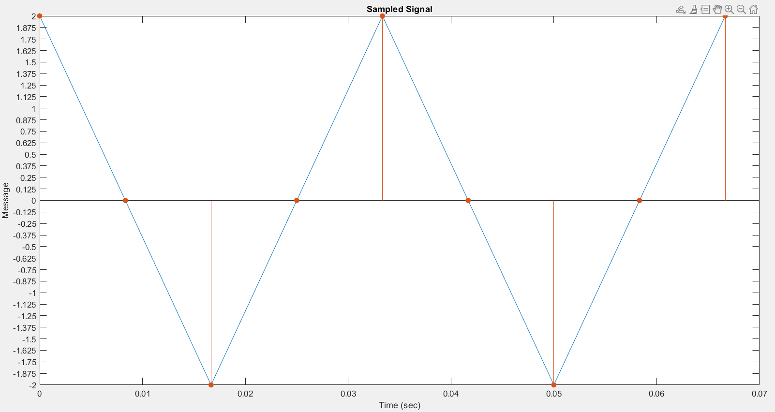

Fig.11

Here, Fs = 2*NR = 2*2*Fm = 120 Hz and Ts = 1/Fs = 1/120 sec.

So, we can see that the samples are taken every quarter period

**Compared to the sampled signal in requirement 1:**

They actually look the same just with more zeros interspersed between the previous samples, because all the added samples are at zero amplitude so they won’t contribute any additional information about the signal’s shape or characteristics

**2- Quantized Signal**

Same as requirement 1:

Number of bits “n” = 3 and Number of levels “L” = 8

Taking the levels as midrise and step size = 0.5

We have Levels at -1.75:0.5:1.75

And the samples are quantized as shown in the figure:

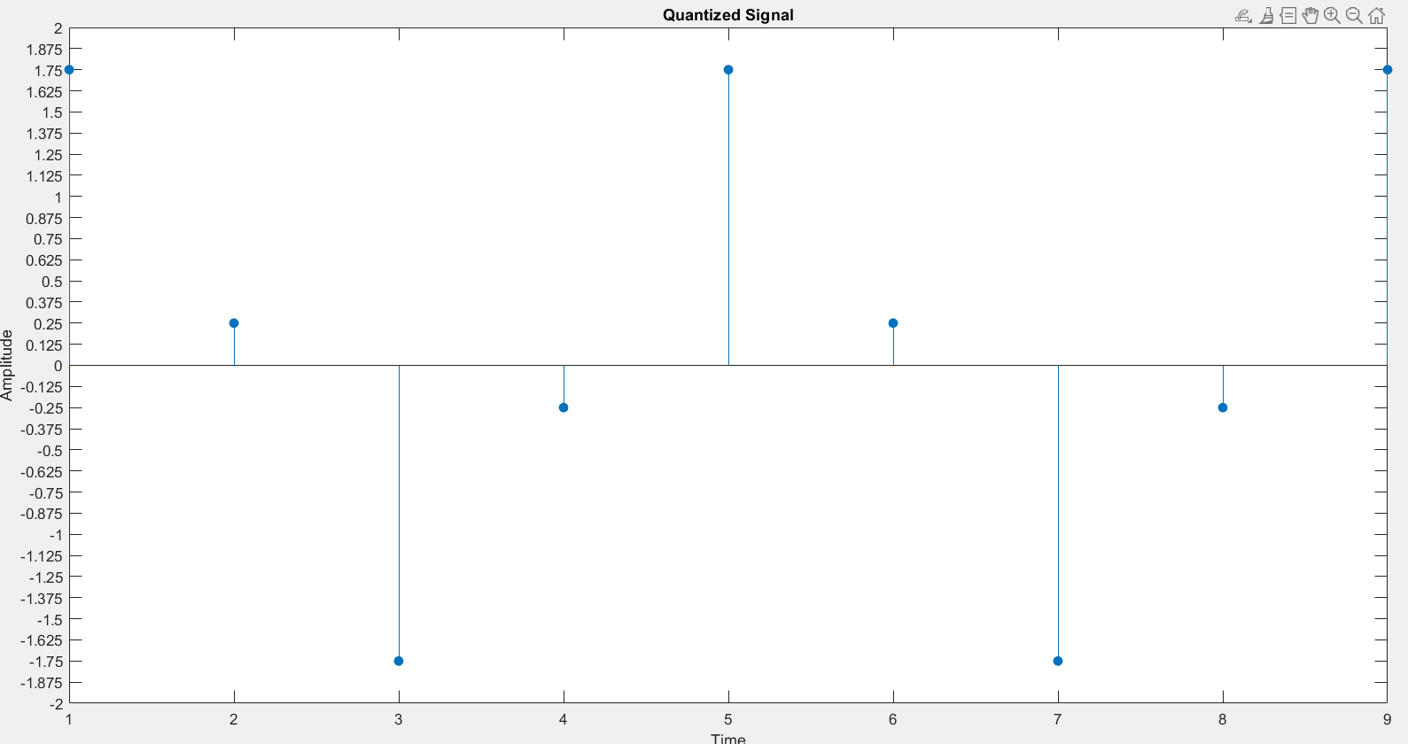

Fig.12

Since, we have more samples than requirement 1 so, there are more quantization values of the input signal despite that the sampled signal isn’t affected, and this is because we’re taking the levels as midrise so the samples which have zero amplitude will have an absolute quantization value of 0.25

**But why some of them have a quantization value of +0.25 and others of -0.25 ?**

Since, the values of the zero amplitude samples are represented as numerical values very close to zero but not exactly zero, one has a positive value that is approximately zero and one has a negative value that is approximately zero and so on….

This is due to the plotting accuracy and numerical precision limitations in matlab and it means that even if you want a number to be zero, due to these limits, the computer might represent it as a very tiny number close to zero instead of exactly zero.

**3- Encoded Signal**

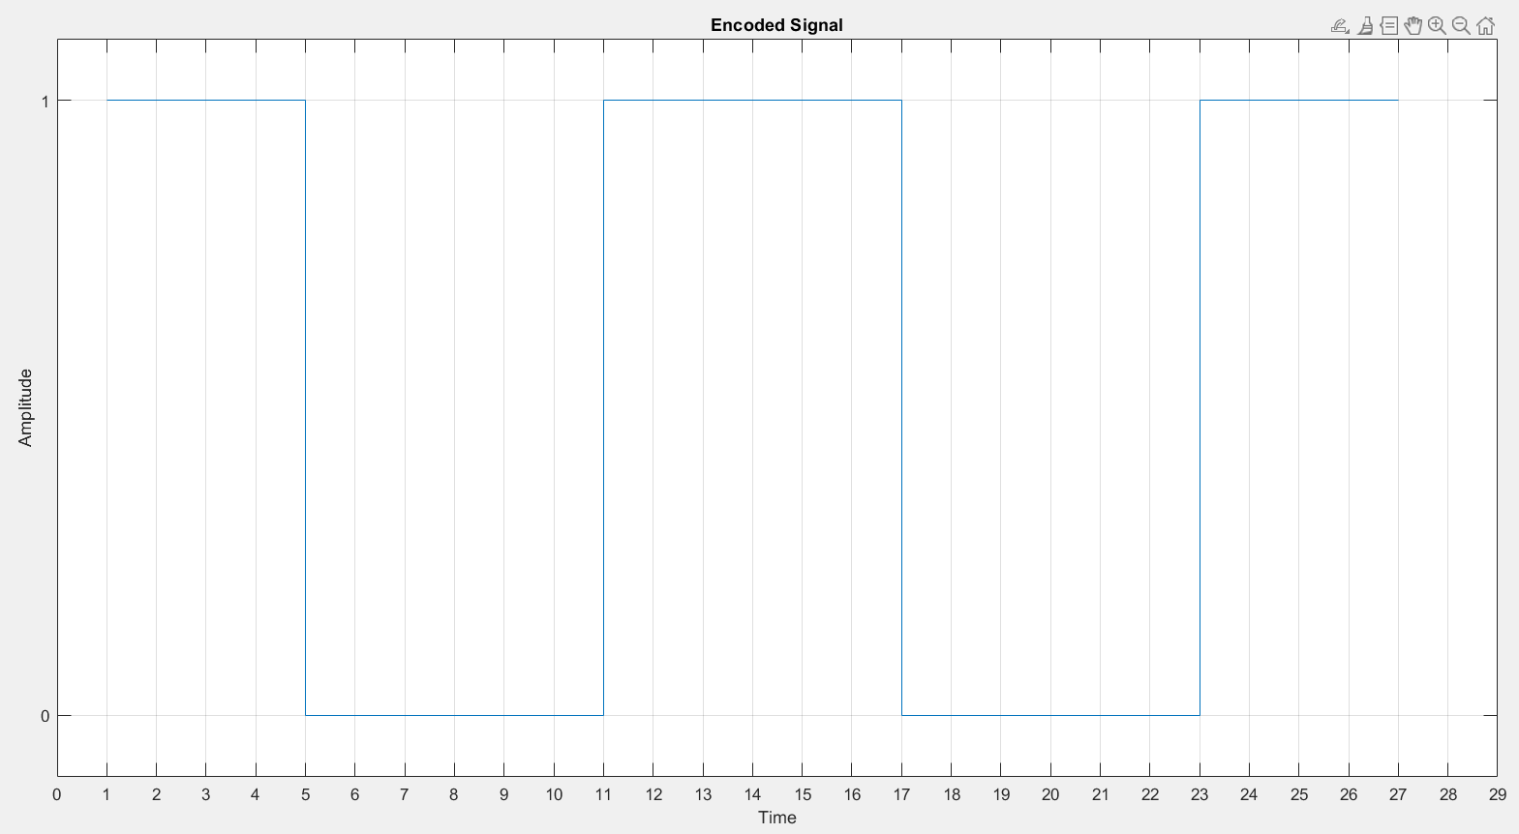

Fig.13

**4- Recovered Signal**

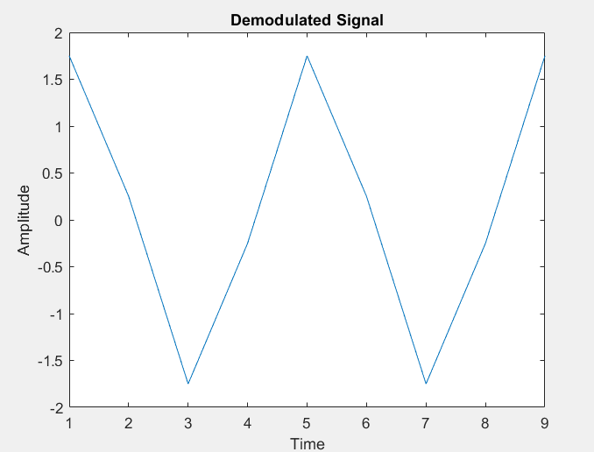

Fig,14

The recovered signal is not the same as the sampled signal due to the distortion introduced by the quantization process and can’t

**But Compared to the recovered signal in requirement 1:**

This signal is a little bit different, since there are more samples so the quantization error is reduced

**5- Bit Rate**

We got Rb = 3*120 = 360 bps

**Requirement 3**

**(If the Sampling rate equals the Nyquist rate)**

**(16 level quantizer)**

**1- The Sampled Signal**

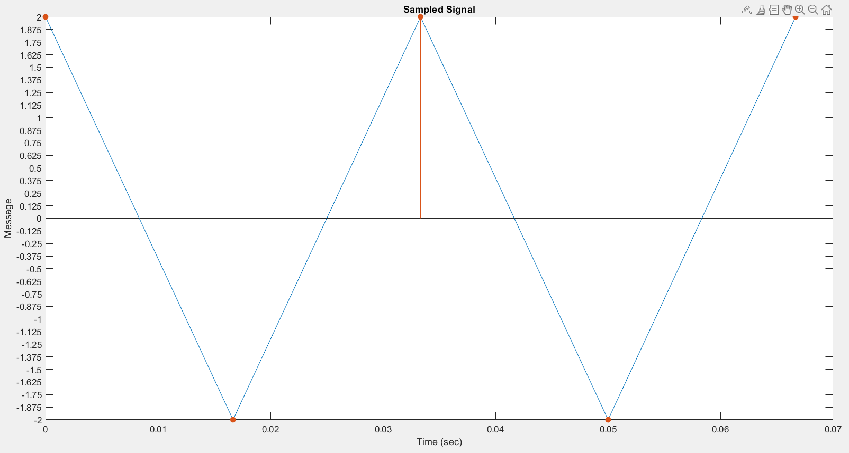

Fig.15

Here, Fs = NR = 2*Fm = 60 Hz and Ts = 1/Fs = 1/60 sec.

So, we can see that the samples are taken every half period as requirement 1

**2- Quantized Signal**

Number of bits “n” = 4 and Number of levels “L” = 16

Taking the levels as midrise and step size = (2-(-2))/16 = 0.25

We have Levels at -1.875:0.25:1.875

And the samples are quantized as shown in the figure:

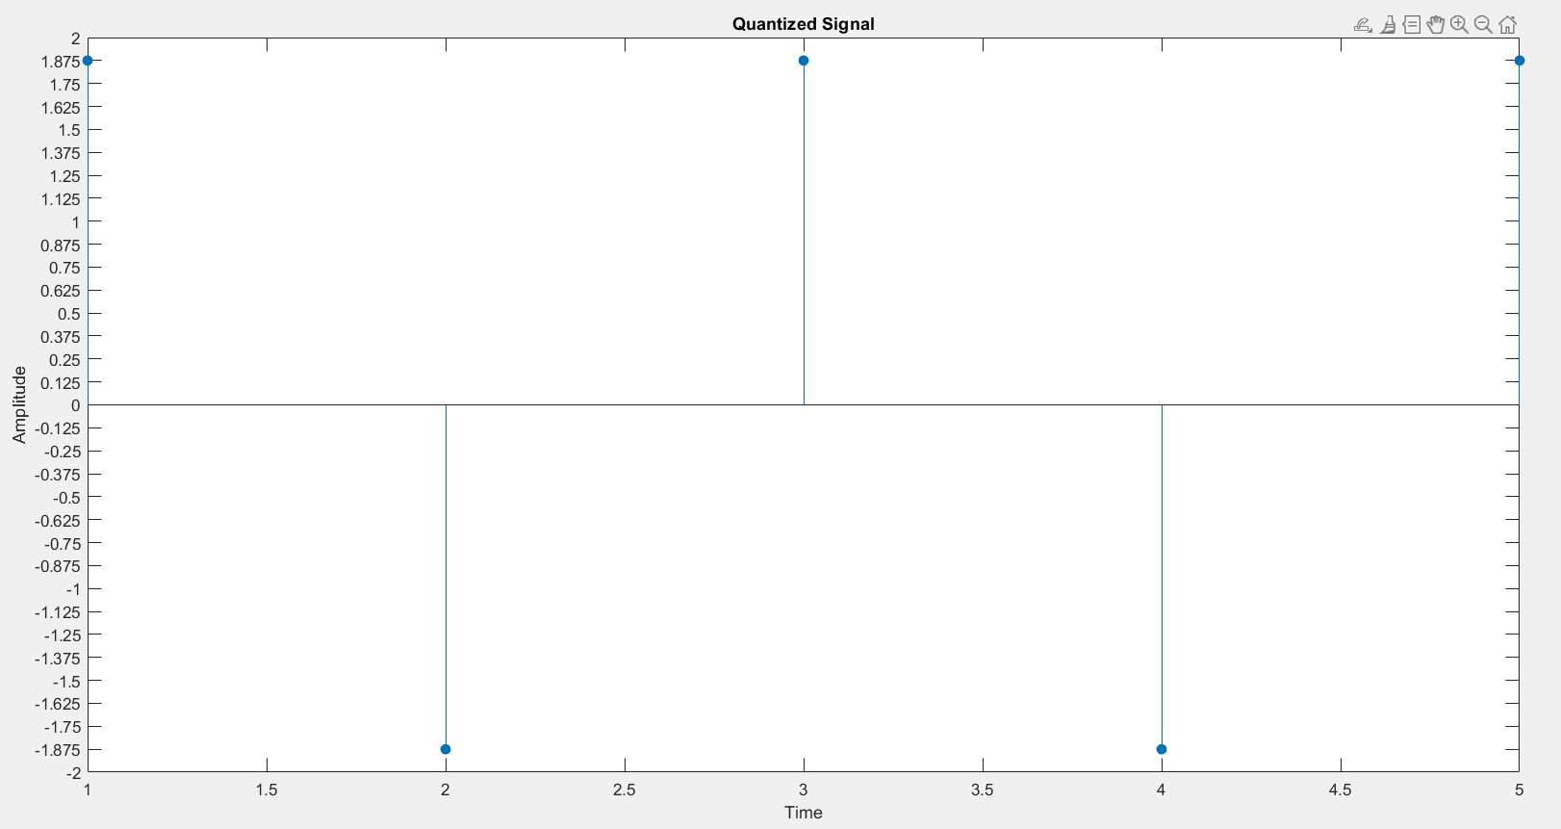

Fig.16

**3- Encoded Signal**

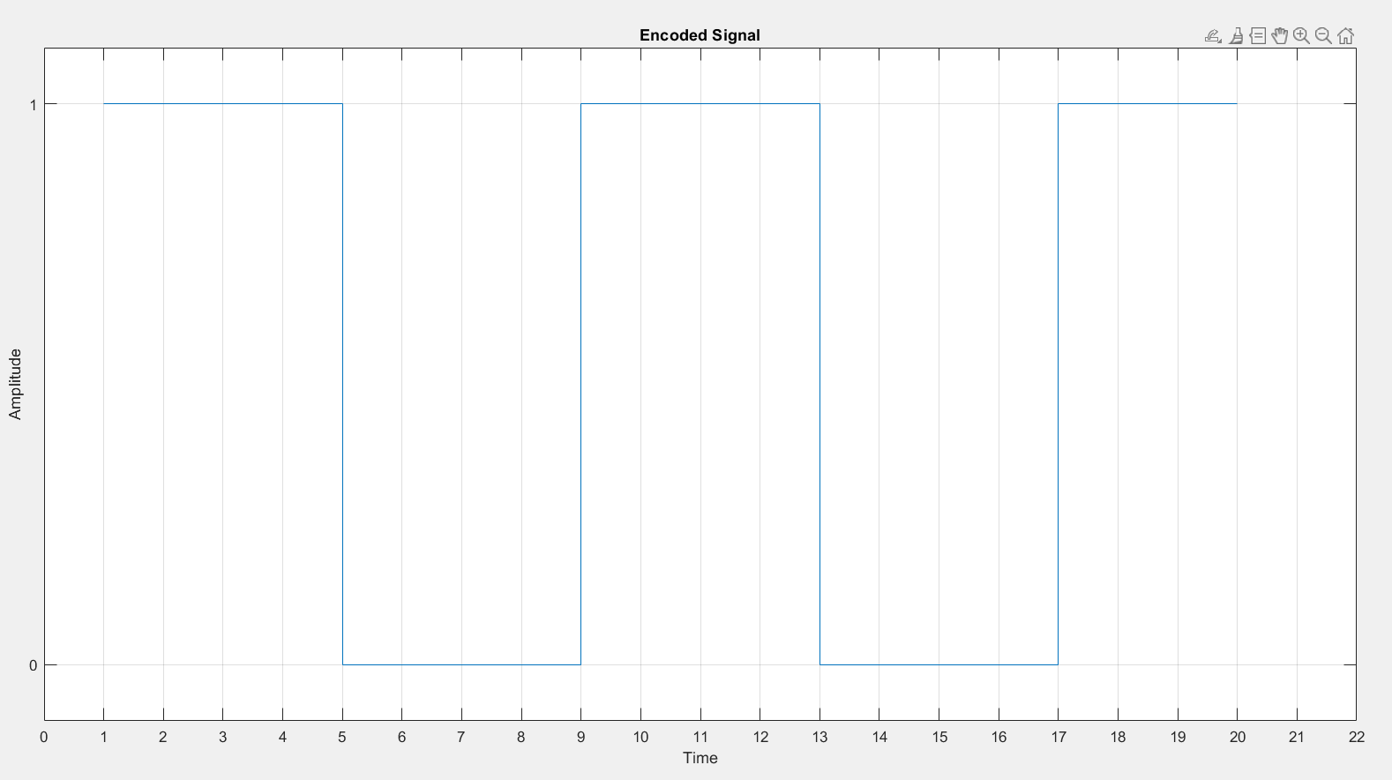

Fig.17

**4- Recovered Signal**

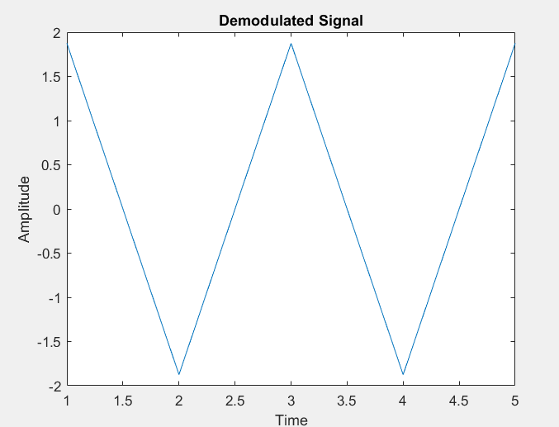

Fig.18

The recovered signal is near to the sampled messaged but there is a less quantization error than requirement 1 because number of level has increased ,and the recovered message is not like the original message because the number is very small to follow the original message.

**5- Bit Rate**

We got Rb = 4*60 = 240 bps